--question 1

-- create tables

CREATE TABLE CUSTOMER (

CUSTOMER_ID INT PRIMARY KEY,

FIRST_NAME VARCHAR(50),

SURNAME VARCHAR(50),

ADDRESS VARCHAR(50),

CONTACT_NUMBER INT,

EMAIL VARCHAR(50)

);

CREATE TABLE EMPLOYEE(

EMPLOYEE_ID VARCHAR(50) PRIMARY KEY,

FIRST_NAME VARCHAR(50),

SURNAME VARCHAR(50),

CONTACT_NUMBER INT,

ADDRESS VARCHAR(50),

EMAIL VARCHAR(50)

);

CREATE TABLE DONATOR(

DONATOR_ID INT PRIMARY KEY,

FIRST_NAME VARCHAR(50),

SURNAME VARCHAR(50),

CONTACT_NUMBER INT,

EMAIL VARCHAR(50)

);

CREATE TABLE DONATION(

DONATION_ID INT PRIMARY KEY,

DONATOR_ID INT,

DONATION VARCHAR(50),

PRICE VARCHAR(50),

DONATION_DATE DATE,

FOREIGN KEY (DONATOR_ID) REFERENCES DONATOR(DONATOR_ID)

);

CREATE TABLE DELIVERY(

DELIVERY_ID INT PRIMARY KEY,

DELIVERY_NOTES VARCHAR(50),

DISPATCH_DATE DATE,

DELIVERY_DATE DATE

);

CREATE TABLE RETURNS(

RETURN_ID VARCHAR(50) PRIMARY KEY,

RETURN_DATE DATE,

REASON VARCHAR(100),

CUSTOMER_ID INT,

DONATION_ID INT,

EMPLOYEE_ID VARCHAR(50),

FOREIGN KEY (CUSTOMER_ID) REFERENCES CUSTOMER(CUSTOMER_ID),

FOREIGN KEY (DONATION_ID) REFERENCES DONATION(DONATION_ID),

FOREIGN KEY (EMPLOYEE_ID) REFERENCES EMPLOYEE(EMPLOYEE_ID)

);

CREATE TABLE INVOICE(

INVOICE_NUM INT PRIMARY KEY,

CUSTOMER_ID INT,

INVOICE_DATE DATE,

EMPLOYEE_ID VARCHAR(50),

DONATION_ID INT,

DELIVERY_ID INT,

FOREIGN KEY (EMPLOYEE_ID) REFERENCES EMPLOYEE(EMPLOYEE_ID),

FOREIGN KEY (DONATION_ID) REFERENCES DONATION(DONATION_ID),

FOREIGN KEY (DELIVERY_ID) REFERENCES DELIVERY(DELIVERY_ID)

);

-- populate tables

--customer table

INSERT INTO CUSTOMER VALUES (11011, 'Jack', 'Smith', '18 Water Rd', '0877277521', 'jsmith@isat.com');

INSERT INTO CUSTOMER VALUES (11012, 'Pat', 'Hendricks', '22 Water Rd', '0863257857', 'ph@mcom.co.za');

INSERT INTO CUSTOMER VALUES (11013, 'Andre', 'Clark', '101 Summer Lane', '0834567891', 'aclark@mcom.co.za');

INSERT INTO CUSTOMER VALUES (11014, 'Kevin', 'Jones', '55 Mountain way', '0612547895', 'kj@isat.co.za');

INSERT INTO CUSTOMER VALUES (11015, 'Lucy', 'Williams', '5 Main rd', '0827238521', 'lw@mcal.co.za');

--employee table

INSERT INTO EMPLOYEE VALUES ('emp101', 'Jeff', 'Davis', '0877277521', '10 main road', 'jand@isat.com');

INSERT INTO EMPLOYEE VALUES ('emp102', 'Kevin', 'Marks', '0837377522', '18 water road', 'km@isat.com');

INSERT INTO EMPLOYEE VALUES ('emp103', 'Adanya', 'Andrews', '0817117523', '21 circle lane', 'aa@isat.com');

INSERT INTO EMPLOYEE VALUES ('emp104', 'Adebayo', 'Dryer', '0797215244', '1 sea road', 'aryer@isat.com');

INSERT INTO EMPLOYEE VALUES ('emp105', 'Xolani', 'Samson', '0827122255', '12 main road', 'xosam@isat.com');

--donor table

INSERT INTO DONATOR VALUES (20111, 'Jeff', 'Watson', '0827172250', 'jwatson@ymail.com');

INSERT INTO DONATOR VALUES (20112, 'Stephen', 'Jones', '0837865670', 'joness@ymail.com');

INSERT INTO DONATOR VALUES (20113, 'James', 'Joe', '0878978650', 'jj@isat.com');

INSERT INTO DONATOR VALUES (20114, 'Kelly', 'Ross', '0826575650', 'kross@gsat.com');

INSERT INTO DONATOR VALUES (20115, 'Abraham', 'Clark', '0797656430', 'aclark@ymail.com');

--donation table

INSERT INTO DONATION VALUES (7111, 20111, 'KIC Fridge', 'R 599', TO_DATE('01-MAY-2024', 'DD-MON-YYYY'));

INSERT INTO DONATION VALUES (7112, 20112, 'Samsung 42inch LCD', 'R 1299', TO_DATE('03-MAY-2024', 'DD-MON-YYYY'));

INSERT INTO DONATION VALUES (7113, 20113, 'Sharp Microwave', 'R 1599', TO_DATE('03-MAY-2024', 'DD-MON-YYYY'));

INSERT INTO DONATION VALUES (7114, 20115, '6 Seat Dining room table', 'R 799', TO_DATE('05-MAY-2024', 'DD-MON-YYYY'));

INSERT INTO DONATION VALUES (7115, 20114, 'Lazyboy Sofa', 'R 1199', TO_DATE('07-MAY-2024', 'DD-MON-YYYY'));

INSERT INTO DONATION VALUES (7116, 20113, 'JVC Surround Sound System', 'R 179', TO_DATE('09-MAY-2024', 'DD-MON-YYYY'));

--delivery table

INSERT INTO DELIVERY VALUES (511, 'Double packaging requested', TO_DATE('10-MAY-2024', 'DD-MON-YYYY'), TO_DATE('15-MAY-2024', 'DD-MON-YYYY'));

INSERT INTO DELIVERY VALUES (512, 'Delivery to work address', TO_DATE('12-MAY-2024', 'DD-MON-YYYY'), TO_DATE('15-MAY-2024', 'DD-MON-YYYY'));

INSERT INTO DELIVERY VALUES (513, 'Signature required', TO_DATE('12-MAY-2024', 'DD-MON-YYYY'), TO_DATE('17-MAY-2024', 'DD-MON-YYYY'));

INSERT INTO DELIVERY VALUES (514, 'No notes', TO_DATE('12-MAY-2024', 'DD-MON-YYYY'), TO_DATE('15-MAY-2024', 'DD-MON-YYYY'));

INSERT INTO DELIVERY VALUES (515, 'Birthday present wrapping required', TO_DATE('18-MAY-2024', 'DD-MON-YYYY'), TO_DATE('19-MAY-2024', 'DD-MON-YYYY'));

INSERT INTO DELIVERY VALUES (516, 'Delivery to work address', TO_DATE('20-MAY-2024', 'DD-MON-YYYY'), TO_DATE('25-MAY-2024', 'DD-MON-YYYY'));

--returns table

INSERT INTO RETURNS VALUES ('ret001', TO_DATE('25-MAY-2024', 'DD-MON-YYYY'), 'Customer not satisfied with product', 11011, 7116, 'emp101');

INSERT INTO RETURNS VALUES ('ret002', TO_DATE('25-MAY-2024', 'DD-MON-YYYY'), 'Product had broken section', 11013, 7114, 'emp103');

--invoice table

INSERT INTO INVOICE VALUES (8111, 11011, TO_DATE('15-MAY-2024', 'DD-MON-YYYY'), 'emp103', 7111, 511);

INSERT INTO INVOICE VALUES (8112, 11013, TO_DATE('15-MAY-2024', 'DD-MON-YYYY'), 'emp101', 7114, 512);

INSERT INTO INVOICE VALUES (8113, 11012, TO_DATE('17-MAY-2024', 'DD-MON-YYYY'), 'emp101', 7112, 513);

INSERT INTO INVOICE VALUES (8114, 11015, TO_DATE('17-MAY-2024', 'DD-MON-YYYY'), 'emp102', 7113, 514);

INSERT INTO INVOICE VALUES (8115, 11011, TO_DATE('17-MAY-2024', 'DD-MON-YYYY'), 'emp102', 7115, 515);

INSERT INTO INVOICE VALUES (8116, 11015, TO_DATE('18-MAY-2024', 'DD-MON-YYYY'), 'emp103', 7116, 516);

--view all data stored in the tables

SELECT * FROM CUSTOMER;

SELECT * FROM EMPLOYEE;

SELECT * FROM DONATOR;

SELECT * FROM DONATION;

SELECT * FROM DELIVERY;

SELECT * FROM RETURNS;

SELECT * FROM INVOICE;

--question 2

-- sql query to generate a report containing customer name, employee id, delivery notes, donation purchased and the invoice number

SELECT

c.FIRST_NAME || ' ' || c.SURNAME AS CUSTOMER_NAME,

i.EMPLOYEE_ID,

d.DELIVERY_NOTES,

don.DONATION AS DONATION_PURCHASED,

i.INVOICE_NUM,

i.INVOICE_DATE

FROM

INVOICE i

JOIN

CUSTOMER c ON i.CUSTOMER_ID = c.CUSTOMER_ID

JOIN

DELIVERY d ON i.DELIVERY_ID = d.DELIVERY_ID

JOIN

DONATION don ON i.DONATION_ID = don.DONATION_ID

WHERE

i.INVOICE_DATE > TO_DATE('16-MAY-2024', 'DD-MON-YYYY');

-- question 3

--create new FUNDING table

CREATE TABLE FUNDING(

FUNDING_ID NUMBER GENERATED ALWAYS AS IDENTITY,

FUNDER VARCHAR(50),

FUNDING_AMOUNT INT

);

--populate table

INSERT INTO FUNDING (FUNDER, FUNDING_AMOUNT) VALUES('Yadav Priaram', 10000);

INSERT INTO FUNDING (FUNDER, FUNDING_AMOUNT) VALUES('Adam Smith', 50000);

--display data in the table

SELECT * FROM FUNDING;

--this solution will create the FUNCTION table and insert the FUNDING_ID, FUNDER, and FUNDING_AMOUNT values.

--the solution will auto generate the FUNDING_ID number making all ID's unique.

--the solution inserts test data into the table to show how the values are stored and how the ID is generated.

--question 4

--PL/SQL query to display customer name, donation purchased, donation price and the reason why the donation was returned.

DECLARE

v_CUSTOMER_NAME VARCHAR2(100);

v_DONATION_PURCHASED VARCHAR2(100);

v_DONATION_PRICE NUMBER;

v_RETURN_REASON VARCHAR2(200);

CURSOR cur_returns IS

SELECT

c.FIRST_NAME || ' ' || c.SURNAME AS CUSTOMER_NAME,

don.DONATION AS DONATION_PURCHASED,

TO_NUMBER(REPLACE(don.PRICE, 'R', '')) AS DONATION_PRICE,

r.REASON AS RETURN_REASON

FROM

RETURNS r

JOIN

CUSTOMER c ON r.CUSTOMER_ID = c.CUSTOMER_ID

JOIN

DONATION don ON r.DONATION_ID = don.DONATION_ID;

BEGIN

FOR rec IN cur_returns LOOP

v_CUSTOMER_NAME := rec.CUSTOMER_NAME;

v_DONATION_PURCHASED := rec.DONATION_PURCHASED;

v_DONATION_PRICE := rec.DONATION_PRICE;

v_RETURN_REASON := rec.RETURN_REASON;

--display the results in the DBMS Output window

dbms_output.put_line('CUSTOMER: ' || v_CUSTOMER_NAME);

dbms_output.put_line('DONATION PURCHASED: ' || v_DONATION_PURCHASED);

dbms_output.put_line('PRICE: R ' || v_DONATION_PRICE);

dbms_output.put_line('RETURN REASON: ' || v_RETURN_REASON);

dbms_output.put_line('--------------------------------------------------');

END LOOP;

dbms_output.put_line('PL/SQL procedure successfully completed.');

END;

--question 5

--PL/SQL query to display customer’s name, employee name, donation, dispatch date and the delivery date

DECLARE

V_CUSTOMER_NAME VARCHAR2(100);

V_EMPLOYEE_NAME VARCHAR2(100);

V_DONATION VARCHAR2(100);

V_DISPATCH_DATE DATE;

V_DELIVERY_DATE DATE;

V_DAYS_TO_DELIVERY NUMBER;

CURSOR cur_delivery IS

SELECT

c.FIRST_NAME || ' ' || c.SURNAME AS CUSTOMER_NAME,

e.FIRST_NAME || ' ' || e.SURNAME AS EMPLOYEE_NAME,

don.DONATION AS DONATION,

TO_DATE(del.DISPATCH_DATE, 'DD/MON/YYYY') AS DISPATCH_DATE,

TO_DATE(del.DELIVERY_DATE, 'DD/MON/YYYY') AS DELIVERY_DATE,

TO_DATE(del.DELIVERY_DATE, 'DD/MON/YYYY') - TO_DATE(del.DISPATCH_DATE, 'DD/MON/YYYY') AS DAYS_TO_DELIVERY

FROM

CUSTOMER c

JOIN

INVOICE inv ON c.CUSTOMER_ID = inv.CUSTOMER_ID

JOIN

EMPLOYEE e ON inv.EMPLOYEE_ID = e.EMPLOYEE_ID

JOIN

DONATION don ON inv.DONATION_ID = don.DONATION_ID

JOIN

DELIVERY del ON inv.DELIVERY_ID = del.DELIVERY_ID

WHERE

c.CUSTOMER_ID = 11011;

BEGIN

FOR rec IN cur_delivery LOOP

v_CUSTOMER_NAME := rec.CUSTOMER_NAME;

v_EMPLOYEE_NAME := rec.EMPLOYEE_NAME;

v_DONATION := rec.DONATION;

v_DISPATCH_DATE := rec.DISPATCH_DATE;

v_DELIVERY_DATE := rec.DELIVERY_DATE;

v_DAYS_TO_DELIVERY := rec.DAYS_TO_DELIVERY;

--display the results in the DBMS Output window

dbms_output.put_line('CUSTOMER: ' || v_CUSTOMER_NAME);

dbms_output.put_line('EMPLOYEE: ' || v_EMPLOYEE_NAME);

dbms_output.put_line('DONATION: ' || v_DONATION);

dbms_output.put_line('DISPATCH DATE: ' || TO_CHAR(v_DISPATCH_DATE, 'DD/MON/YY'));

dbms_output.put_line('DELIVERY DATE: ' || TO_CHAR(v_DELIVERY_DATE, 'DD/MON/YY'));

dbms_output.put_line('DAYS TO DELIVERY: ' || v_DAYS_TO_DELIVERY);

dbms_output.put_line('--------------------------------------------------');

END LOOP;

END;

--question 6

--PL/SQL query to display customer name and total amount spent by each customer on the purchases

DECLARE

CURSOR customer_cursor IS

SELECT

c.FIRST_NAME,

c.SURNAME,

SUM(TO_NUMBER(REGEXP_SUBSTR(don.PRICE, '[0-9]+'))) AS AMOUNT,

CASE

WHEN SUM(TO_NUMBER(REGEXP_SUBSTR(don.PRICE, '[0-9]+'))) >= 1500 THEN '***'

ELSE NULL

END AS RATING

FROM

CUSTOMER c

JOIN

INVOICE inv ON c.CUSTOMER_ID = inv.CUSTOMER_ID

JOIN

DONATION don ON inv.DONATION_ID = don.DONATION_ID

GROUP BY

c.FIRST_NAME, c.SURNAME;

v_first_name CUSTOMER.FIRST_NAME%TYPE;

v_surname CUSTOMER.SURNAME%TYPE;

v_amount NUMBER;

v_rating VARCHAR2(3);

BEGIN

FOR customer_record IN customer_cursor LOOP

v_first_name := customer_record.FIRST_NAME;

v_surname := customer_record.SURNAME;

v_amount := customer_record.AMOUNT;

v_rating := customer_record.RATING;

--display results in the DBMS Output window

DBMS_OUTPUT.PUT_LINE('FIRST NAME: ' || v_first_name);

DBMS_OUTPUT.PUT_LINE('SURNAME: ' || v_surname);

DBMS_OUTPUT.PUT_LINE('AMOUNT: R ' || v_amount || v_rating);

DBMS_OUTPUT.PUT_LINE('----------------------------------------------------');

END LOOP;

END;

--question 7

--Q 7.1

--example of the %TYPE attribute

DECLARE

v_funder_name FUNDING.FUNDER%TYPE;

v_funding_amount FUNDING.FUNDING_AMOUNT%TYPE;

BEGIN

v_funder_name := 'Yadav Priaram';

v_funding_amount := 5000;

dbms_output.put_line('Funder Name: '|| v_funder_name);

dbms_output.put_line('Funding Amount: R ' || v_funding_amount);

END;

/

--Q7.2

--Example of the %ROWTYPE attribute

DECLARE

v_funding_record FUNDING%ROWTYPE;

BEGIN

SELECT *

INTO v_funding_record

FROM FUNDING

WHERE FUNDING_ID = 1;

dbms_output.put_line('Funder Name: ' || v_funding_record.FUNDER);

dbms_output.put_line('Funding Amount: R ' || v_funding_record.FUNDING_AMOUNT);

END;

/

--Q7.3

--for this question, i will create a user defined excpetion which will ensure that donations are a minimum of R10

DECLARE

V_DONATION_AMOUNT NUMBER := 30; --INSERT DONATION AMOUNT

INSUFFICIENT_DONATION EXCEPTION;

BEGIN

IF V_DONATION_AMOUNT < 10 THEN

RAISE INSUFFICIENT_DONATION;

END IF;

DBMS_OUTPUT.PUT_LINE('Thank you for your donation: R ' || v_donation_amount);

EXCEPTION

WHEN INSUFFICIENT_DONATION THEN

DBMS_OUTPUT.PUT_LINE('Error: Kindly note that the minimum donation amount is R10.');

END;

/

--Question 8

--sql query to display the customer name and total amount spent by each customer on the purchases with a rating

SELECT

c.FIRST_NAME,

c.SURNAME,

SUM(TO_NUMBER(REPLACE(don.PRICE, 'R', ''))) AS TOTAL_AMOUNT_SPENT,

CASE

WHEN SUM(TO_NUMBER(REPLACE(don.PRICE, 'R ', ''))) >= 1500 THEN '***'

WHEN SUM(TO_NUMBER(REPLACE(don.PRICE, 'R ', ''))) BETWEEN 1000 AND 1400 THEN '**'

ELSE '*'

END AS CUSTOMER_RATING

FROM

CUSTOMER c

JOIN

INVOICE inv ON c.CUSTOMER_ID = inv.CUSTOMER_ID

JOIN

DONATION don ON inv.DONATION_ID = don.DONATION_ID

GROUP BY

c.FIRST_NAME, c.SURNAME

Screenshots

Question 1

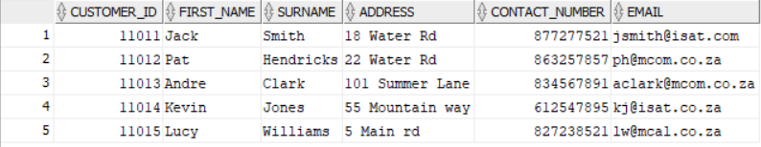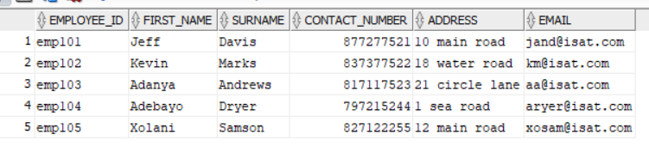

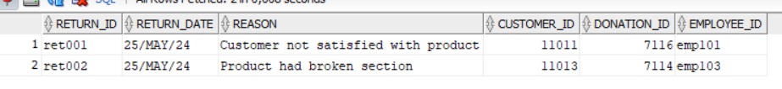

Question 2

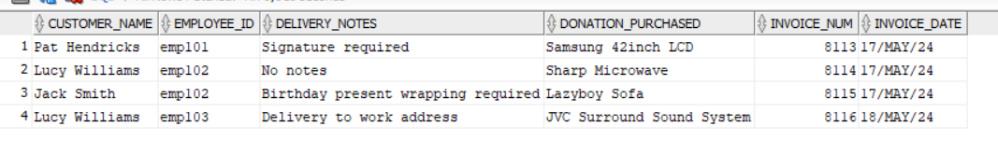

Question 3

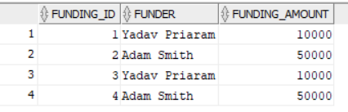

Question 4

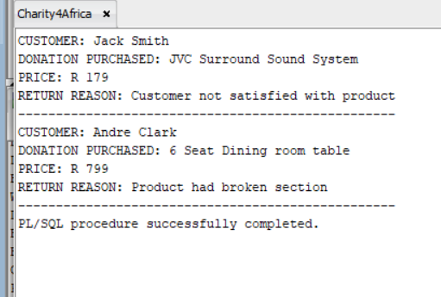

Question 5

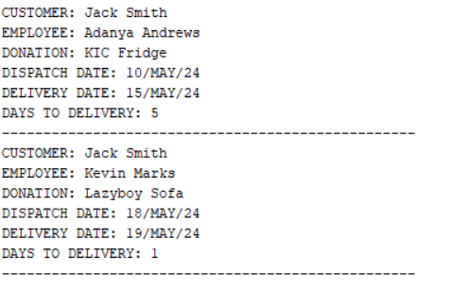

Question 6

Question 7

Q7.1

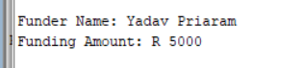

Q7.2

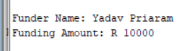

Q7.3

Both scenarios

Question 8

Reference list

(No date) *%ROWTYPE attribute*. Available at: <https://docs.oracle.com/cd/B12037_01/appdev.101/b10807/13_elems042.htm> (Accessed: 06 October 2024).

*Loading...: Sap help portal* (no date) *loading... | SAP Help Portal*. Available at: <https://help.sap.com/docs/SAP_SQL_Anywhere/93079d4ba8e44920ae63ffb4def91f5b/817fb5486ce21014a388d42b2805512a.html#:~:text=The%20%25TYPE%20attribute%20sets%20the,type%20information%20from%20system%20tables>. (Accessed: 06 October 2024).

*Oracle Identity Column: A step-by-step guide with examples* (2023) *Oracle Tutorial*. Available at: <https://www.oracletutorial.com/oracle-basics/oracle-identity-column/> (Accessed: 06 October 2024).

*PL/SQL - exceptions* (no date) *Tutorialspoint*. Available at: <https://www.tutorialspoint.com/plsql/plsql_exceptions.htm> (Accessed: 06 October 2024).

*PL/SQL - procedures* (no date) *Tutorialspoint*. Available at: <https://www.tutorialspoint.com/plsql/plsql_procedures.htm> (Accessed: 06 October 2024).

*SQL Reference Guide* (2022) *Oracle Help Center*. Available at: <https://docs.oracle.com/en/database/other-databases/nosql-database/21.2/sqlreferencefornosql/identity-column.html#:~:text=CREATE%20TABLE%20T1%20(%20id%20INTEGER,primary%20key%20for%20table%20T>. (Accessed: 06 October 2024).

*W3schools.com* (no date) *SQL Stored Procedures*. Available at: <https://www.w3schools.com/sql/sql_stored_procedures.asp> (Accessed: 06 October 2024).